**APPENDIX A: Course Detail Sheet for project**

Course Detail Sheet

|  |  |  |  |  |  |  |  |  |  |
| --- | --- | --- | --- | --- | --- | --- | --- | --- | --- |
| Programme: 2019 | | | Class: B.E(E&TC) | | | | | AY 2022-23  Sem. I&II | |
| Course Code: 404188 & 404197 | | | Course Project Phase-I and Project Phase-II | | | | | | |
| Course Teacher: Project Guides | | | Department: Electronics and Telecommunication Engineering | | | | | | |
| Teaching Scheme | | | Examination Scheme | | | | | | |
| Theory | Practical | Tutorial | Theory | | | Lab | | | |
| (hrs/week) | (hrs/week) | (hrs/week) | ~~Online~~/  Insem | Endsem | Sessional | Term Work | Practical | | Oral |
| ---- | ---- | 2+6 hrs | --- | --- | --- | 100 | --- | | 50+50 |
| **Abstract:** By learning this subject students will be able to Identify complex problem and define the methodology to solve the problem. Construct, analyze and approach problem solution as a team, plan, and co-ordinate and control the complex and diverse activities in project. Design appropriately using a modular construction approach to solve the problem as per specifications and implement the selected methodology to solve the problem by selecting the correct hardware according to specifications and software for simulation and programming and develop leadership skills by aligning with the objective of the project and lead the team towards its goal  **Prerequisite:** All Subjects of E&TC Engineering | | | | | | | | | |

**Delivery Methods (DM)**

|  |  |  |  |  |  |  |  |
| --- | --- | --- | --- | --- | --- | --- | --- |
| **Chalk & Talk** | **ICT Tools** | **Group Discussion** | **Industrial/**  **Field Visit** | **Expert Talk** | **Survey** | **Mini project** | **Lab** |
| **--** | √ | **--** | **--** | **--** | √ | **--** | -- |

**Course Outcomes (COs)**

|  |  |
| --- | --- |
| **Course Outcome** | **After successful completion of course students will be able to** |
| CO1 | Define, analyze and solve complex real life problem. |
| CO2 | Work in collaborative team as a member or leader. |
| CO3 | Apply project management techniques. |
| CO4 | Identify and apply appropriate tools. |
| CO5 | Communicate effectively in verbal and written form. |
| CO6 | Imbibe ethical practices. |

|  |  |
| --- | --- |
| **Learning objective for CO1**  **Students will be able to:** | |
| 1 | Identify specification of the problem. |
| 2 | Structure the problem. |
| 3 | Identify the appropriate methodology to solve the problem. |
| 4 | Define the methodology to solve the problem. |
| **Learning objective for CO2**  **Students will be able to:** | |
| 1 | Adapt the vital skills of compromise and collaboration. |
| 2 | Construct , analyzes and approach problem solution as a team |
| 3 | Fully understand the role of each individual in a group to accomplish the goal. |
| 4 | Develop leadership skills by aligning with the objective of the project and lead the team towards its goal. |
| **Learning objective for CO3**  **Students will be able to** | |
| 1 | Plan, co-ordinate and control the complex and diverse activities in project |
| 2 | Predict any problems and find solution for it |
| 3 | Plan the progress to result in total completion of the project. |
| **Learning objective for CO4**  **Students will be able to** | |
| 1 | Design appropriately using a modular construction approach to solve the problem as per specifications. |
| 2 | Implement the selected methodology to solve the problem. |
| 3 | Select the correct hardware according to specifications. |
| 4 | Select the correct software for simulation and programming. |
| 5 | Validate the result and draw conclusion. |
| **Learning objective for CO5**  **Students will be able to** | |
| 1 | Present the work done by proper documentation |
| 2 | Present paper in national / international conferences, project exhibitions & competitions |
| **Learning objective for CO6**  **Students will** | |
| 1 | Develop professional practice. |
| 2 | Recognize how *to do the project to its best.* |
| 3 | Develop ethical Practices. |

**Mapping of Course Objectives to Course Outcomes:**

|  |  |  |  |  |  |  |
| --- | --- | --- | --- | --- | --- | --- |
| Course Objective | Course Outcomes | | | | | |
|  |  |  |  |  |  |
| C-I |  |  |  |  |  |  |
| C-II |  |  |  |  |  |  |
| C-III |  |  |  |  |  |  |
| C-IV |  |  |  |  |  |  |
| C-V |  |  |  |  |  |  |
| C-VI |  |  |  |  |  |  |

**Program Outcomes (POs):**

**Engineering Graduates will be able to:**

1. **Engineering knowledge:** Apply the knowledge of mathematics, science, engineering fundamentals, and an engineering specialization to the solution of complex engineering problems.

**2**. **Problem analysis:** Identify, formulate, review research literature, and analyze complex engineering problems reaching substantiated conclusions using first principles of mathematics, natural sciences, and engineering sciences.

**3.** **Design/development of solutions:** Design solutions for complex engineering problems and design system components or processes that meet the specified needs with appropriate consideration for the public health and safety, and the cultural, societal, and environmental considerations.

**4.** **Conduct investigations of complex problems:** Use research-based knowledge and research methods including design of experiments, analysis and interpretation of data, and synthesis of the information to provide valid conclusions.

**5. Modern tool usage:** Create, select, and apply appropriate techniques, resources, and modern engineering and IT tools including prediction and modeling to complex engineering activities with an understanding of the limitations.

**6.** **The engineer and society:** Apply reasoning informed by the contextual knowledge to assess societal, health, safety, legal and cultural issues and the consequent responsibilities relevant to the professional engineering practice.

**7. Environment and sustainability:** Understand the impact of the professional engineering solutions in societal and environmental contexts, and demonstrate the knowledge of, and need for sustainable development.

**8. Ethics:** Apply ethical principles and commit to professional ethics and responsibilities and norms of the engineering practice.

**9. Individual and team work:** Function effectively as an individual, and as a member or leader in diverse teams, and in multidisciplinary settings.

**10. Communication:** Communicate effectively on complex engineering activities with the engineering community and with society at large, such as, being able to comprehend and write effective reports and design documentation, make effective presentations, and give and receive clear instructions.

**11.** **Project management and finance:** Demonstrate knowledge and understanding of the engineering and management principles and apply these to one’s own work, as a member and leader in a team, to manage projects and in multidisciplinary environments.

**12.** **Life-long learning:** Recognize the need for, and have the preparation and ability to engage in independent and life-long learning in the broadest context of technological change.

**Program Specific Outcomes (PSO):**

1. Analyze and designelectronic systems for hybrid engineering application.

2. Implement functional blocks of hardware, software or hardware-software co-design for signal processing and communication applications.

Mapping of Course Outcome (CO) with

Program Outcome (PO) and Program Specific Outcome (PSO)

1: Slight (Low) 2: Moderate (Medium) 3: Substantial (High)

If there is no correlation, put **“-“**

|  |  |  |  |  |  |  |  |  |  |  |  |  |  |  |
| --- | --- | --- | --- | --- | --- | --- | --- | --- | --- | --- | --- | --- | --- | --- |
|  | **PO1** | **PO2** | **PO3** | **PO4** | **PO5** | **PO6** | **PO7** | **PO8** | **PO9** | **PO10** | **PO11** | **PO12** | **PSO1** | **PSO2** |
| CO404188.1  &  CO404195.1 | 3 | 3 | 3 | 3 | 3 | 3 | 3 | - | - | - | - | - | 3* | 3* |
| CO404188.2  &  CO404195.2 | - | - | - | - | - | - | - | - | 3 | - | 2 | - | - | - |
| CO404188.3  &  CO404195.3 | - | - | - | - | - | - | - | - | - | - | 3 | 2 | - | - |
| CO404188.4  &  CO404195.4 | 2 | 2 | - | 3 | 3 | - | - | - | - | - | - | 2 | - | - |
| CO404188.5  &  CO404195.5 | - | - | - | - | - | - | - | - | - | 3 | - | - | - | - |
| CO404188.6  &  CO404195.6 | - | - | - | - | - | - | - | 3 | - | - | - | - | - | - |
| Average | 2.5 | 2.5 | 3 | 3 | 3 | 3 | 2 | 3 | 3 | 3 | 2.5 | 2 | 3* | 3* |

**Course-PO matrix**

|  |  |  |  |  |  |  |  |  |  |  |  |  |  |  |
| --- | --- | --- | --- | --- | --- | --- | --- | --- | --- | --- | --- | --- | --- | --- |
|  | **PO1** | **PO2** | **PO3** | **PO4** | **PO5** | **PO6** | **PO7** | **PO8** | **PO9** | **PO10** | **PO11** | **PO12** | **PSO1** | **PSO2** |
| **404188 & 404197** | 2.5 | 2.5 | 3 | 3 | 3 | 3 | 3 | 3 | 3 | 3 | 2.5 | 2 | 3* | 3* |

|  |  |  |  |
| --- | --- | --- | --- |
|  |  |  |  |
|  |  |  |  |
|  |  |  |  |
|  |  |  |  |
|  |  |  |  |
|  |  |  |  |
|  |  |  |  |
|  |  |  |  |
|  |  |  |  |
|  |  |  |  |
|  |  |  |  |
|  |  |  |  |
|  |  |  |  |
|  |  |  |  |

**APPENDIX B: Certificate and Report for Plagiarism Check**

**Plagiarism Certificate**

This is to certify that the project work titled “ Design and Implementation of Safety features for Automotive ”, is a part of project work carried out by “ Tejas Vilas Chaudhari (B190133012), Avirat Dipak Labhade (B190133041), Yash Sachin Sangale (B190133059) ”

under the guidance of Prof Prof. Dr. S.A.Patil (Ugale) at K. K. Wagh Institute of Engineering Education and Research, Nashik, in the partial fulfillment of the requirements for Bachelor’s degree in Electronics and Telecommunication Engineering.

To the best of our knowledge, the work included in this report is an original work carried out by us independently. The percentage of plagiarism is **1%**. The results of the project work in part or whole have not been submitted to any other Institute/University for the award of any degree.

1. Tejas Vilas Chaudhari
2. Avirat Dipak Labhade
3. Yash Sachin Sangale

Name & Signature of the student

**APPENDIX C: Data sheets(special)**

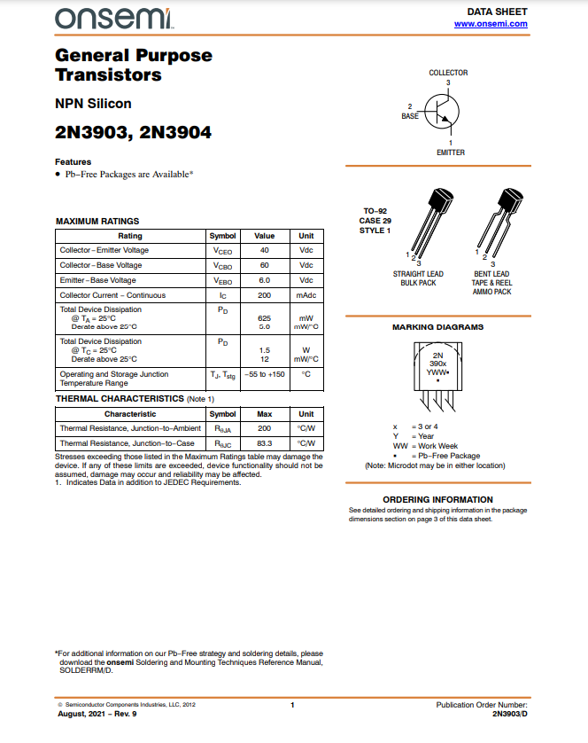

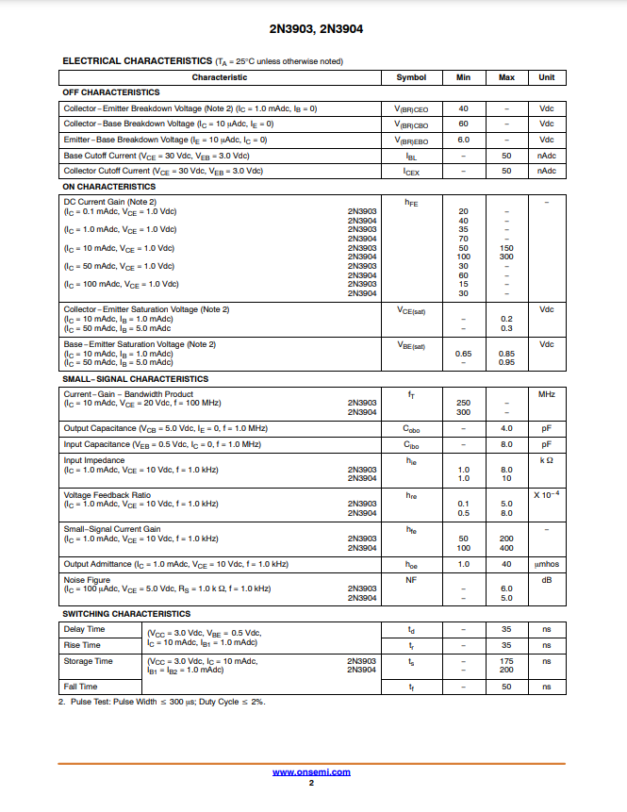

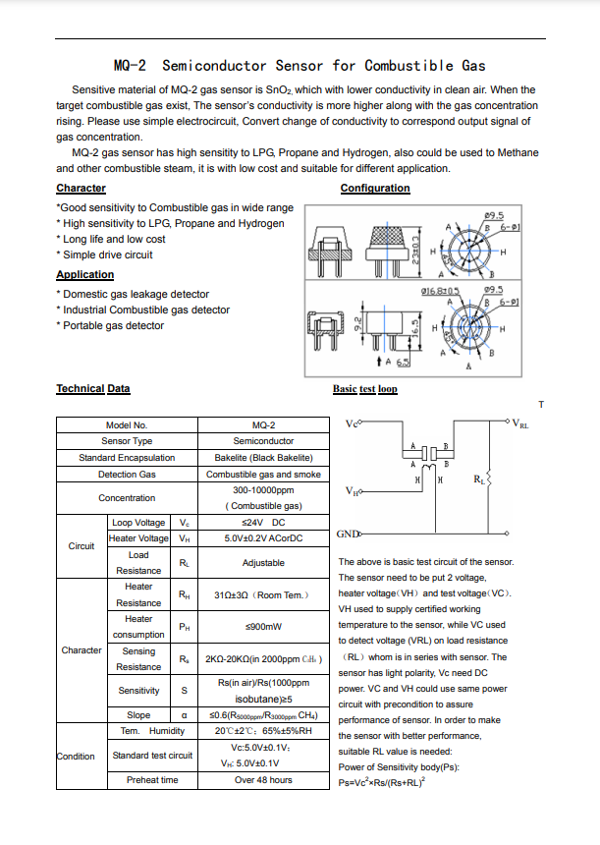

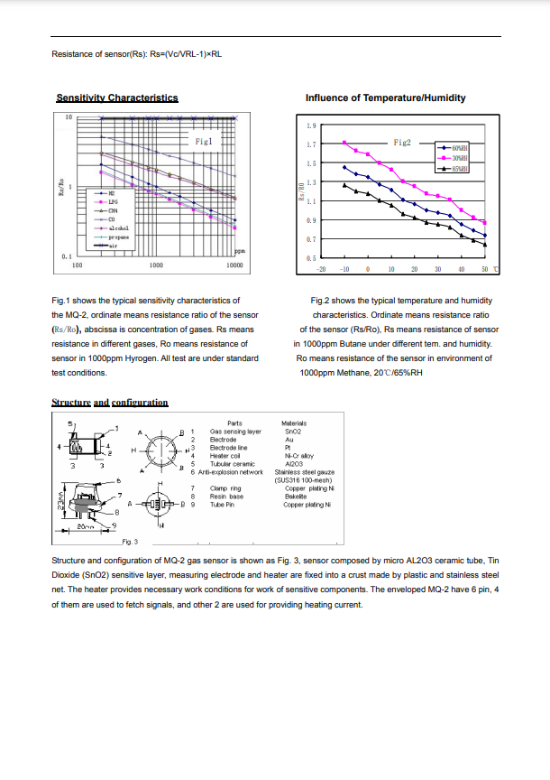

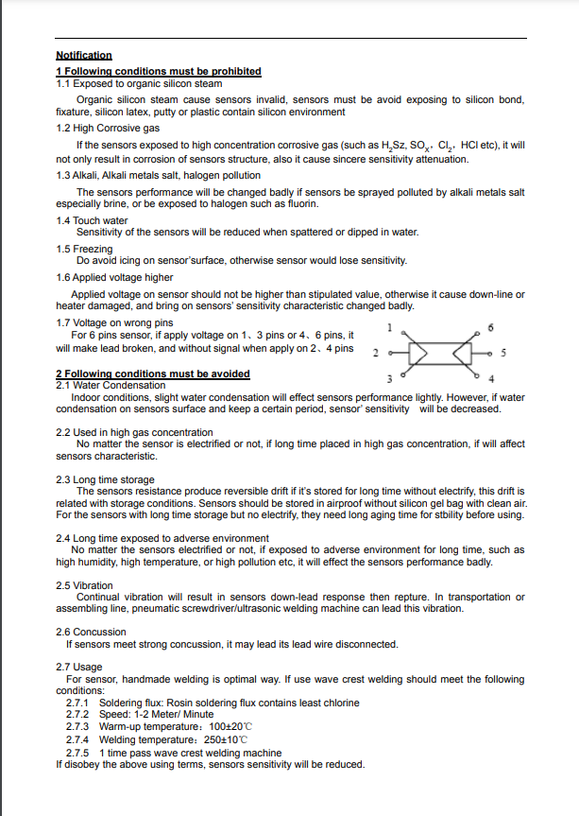

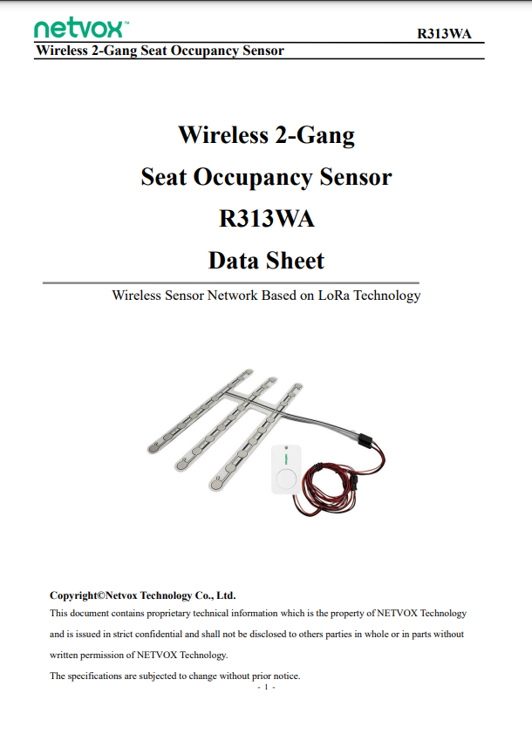

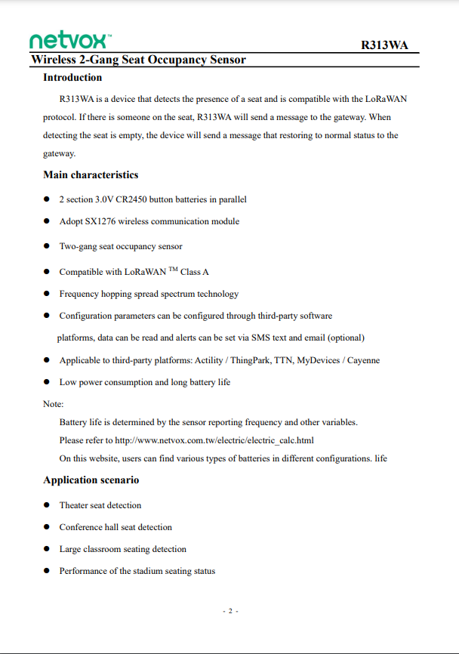

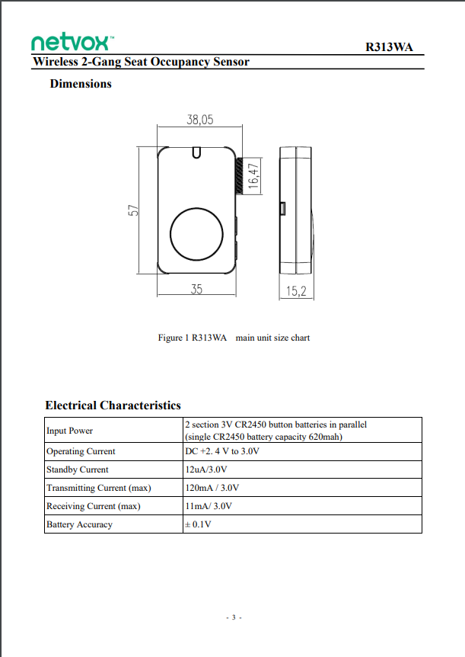

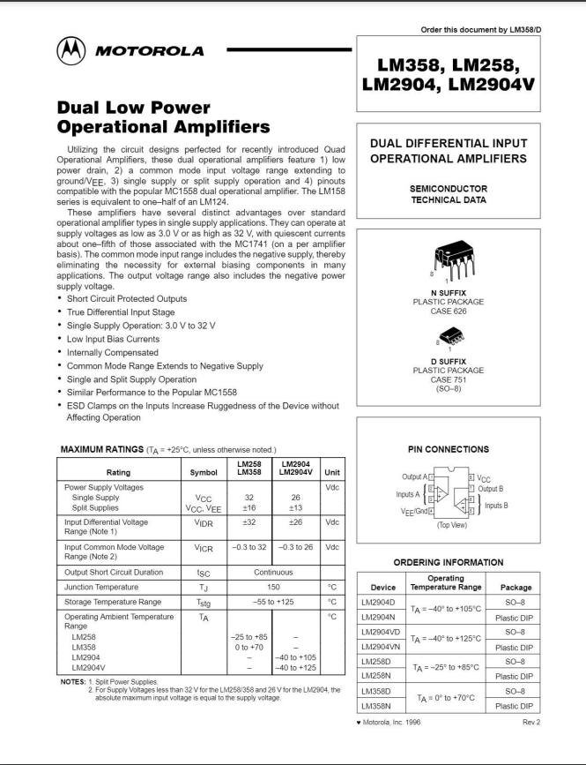

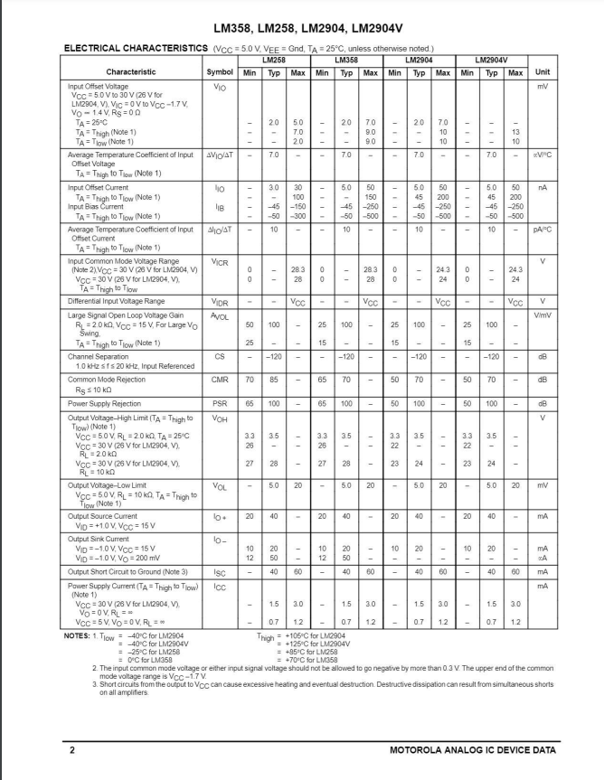

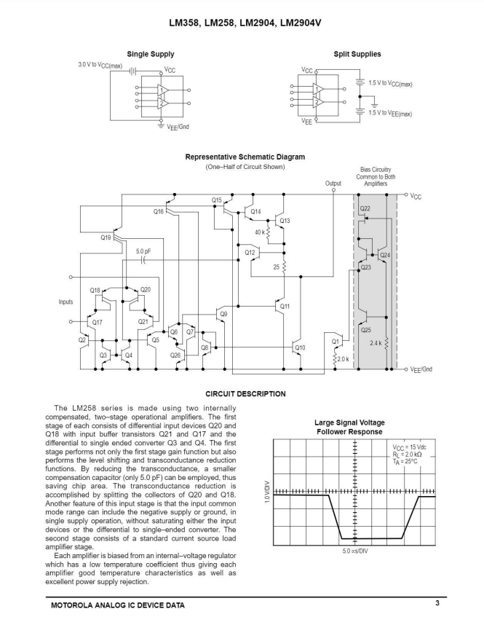

**APPENDIX D: Rubrics for Project Phase-I and Phase-II**

**Review-I**

|  |  |  |  |  |
| --- | --- | --- | --- | --- |
| Sr.No. | Criterion | **Excellent** | **Good** | **Beginner** |
| 1 | Problem Definition (5) | Problem Statement clearly defined. (5-4) | Problem Statement partially defined. (4-2) | Problem Statement not defined. (2-0) |
| 2 | Scope & Objectives (10) | Description of scope of project is clearly stated and objective of project is clear (10-8) | Description of scope of project is somewhat clearly stated and objective is somewhat clear (8-5) | Scope and Objective of project is not clear (5-0) |
| 3 | Literature Review (10) | Many and relevant  IEEE paper refereed.  Comprehensive review providing a good basis for the project. Entire Coverage with relevant and accurate support. (10-8) | Few and relevant  Papers Referred but not IEEE. Systematic survey attempted but incomplete and inconsistent. Little coverage and less accurate support. (8-5) | Very few and no relevant papers referred. No evidence of research been conducted. (5-0) |
| 4 | Methodology (10) | Methodologies which will be used are clearly described.  (10-8) | Methodology which will be used are partially described  (8-5) | Methodology are not described  (5-0) |
| 5 | Block Diagram / Architecture (10) | Block Diagram and Design is Correct. (10-8) | Block Diagram and Design is partially Correct (8-5) | Block Diagram and Design is incorrect (5-0) |
| 6 | Project Planning (5) | Highly effective use of available resources.  Effective management of workload  (5-4) | Moderate use of available resources.  Less effective management of workload  (4-2) | No use of available resources  No management of workload.  (2-0) |
|  | Total (50) | (50-40) | (40-27) | (25-0) |

**Review-II**

|  |  |  |  |  |
| --- | --- | --- | --- | --- |
| Sr.No. | Criterion | **Excellent** | **Good** | **Beginner** |
| 1 | Requirement Specification (10) | Properly stated and correct Specification (10-8) | Not clearly stated and incorrect Specification (8-5) | Not Properly stated and incorrect Specification (5-0) |
| 2 | Literature Review (5) | Additional improvement in the Literature Review  (5-4) | Less improvement in the Literature Review  (4-2) | No improvement in the Literature Review  (2-0) |
| 3 | Detailed Design (10) | Designing is stated correctly  (10-8) | Design is partially correct  (8-5) | Designing is not correct  (5-0) |
| 4 | Experimental Setup / Simulation (10) | Proper simulation and correct Experimental Setup  (10-8) | Simulation and Experimental Setup is partially correct  (8-5) | Simulation and Experimental Setup is not done. (5-0) |
| 5 | Performance Parameters (10) | Performance Parameters are stated clearly. (10-8) | Performance Parameters partially stated. (8-5) | Performance Parameters not stated. (5-0) |
| 6 | Efficiency Issues (5) | Efficiency Issues addressed.  (5-4) | Efficiency Issues partially addressed.  (4-2) | Efficiency Issues not addressed.  (2-0) |
|  | Total (50) | (50-40) | (40-27) | (25-0) |

**Stage-I Documentation**

|  |  |  |  |  |
| --- | --- | --- | --- | --- |
| Sr.No. | Criterion for (Project Stage-I) | **Excellent** | **Good** | **Beginner** |
| 1 | Documentation (50) | All Contents are covered with the given format and well organized report. (50-40) | Content are covered but the format is not proper and somewhat organized report. (40-20) | Content are not covered, format is not proper and report not organized. (<20) |

|  |  |
| --- | --- |
| Sr.No. | Criterion |
|
| 1 | Project Review 1 (50) |
| 2 | Project Review 2 (50) |
| 3 | Documentation (Project Stage-I Report) (50) |
|  | Average of Review-1, Review-2 and Documentation stage is taken for 50 marks Evaluation |

**Review –III**

|  |  |  |  |  |
| --- | --- | --- | --- | --- |
| Sr.No. | Criterion | **Excellent** | **Good** | **Beginner** |
| 1 | Revised Final Design (10) | Final Design is correct (10-8) | Final Design is somewhat correct (8-5) | Design is incorrect, to be revised again (5-0) |
| 2 | Tools and Techniques Used (10) | Appropriate tools and techniques used(10-8) | Tools and techniques to some extent only used  (8-5) | Tools and techniques not used(5-0) |
| 3 | Partial Implementation (15) | Project is partially implemented (15-12) | Project implementation is just started. (12-7) | Project implementation is not yet started.  (7-0) |
| 4 | Partial Results (15) | Partial Results are correct.  (15-12) | Partial results are somewhat correct. (12-8) | Results not obtained. (8-0) |
|  | Total (50) | (50-40) | (40-25) | (25-0) |

**Review –IV**

|  |  |  |  |  |
| --- | --- | --- | --- | --- |
| Sr.No. | Criterion | **Excellent** | **Good** | **Beginner** |
| 1 | Implementation Status (10) | Project implementation is complete. (10-8) | Project implementation is partially completed.  (8-5) | Project implementation is incomplete. (5-0) |
| 2 | Modular Testing (10) | Modular testing is correct (10-8) | Modular testing is somewhat correct(8-5) | Modular testing is incorrect.  (5-0) |
| 3 | Intermediate Results (15) | Desired results are shown  (15-12) | Results are partially shown.  (12-8) | Results are not obtained. (8-0) |
| 4 | Conclusion and Future Scope (10) | Conclusion and future scope are clearly stated (10-8) | Conclusion and future scope are somewhat clearly stated (8-5) | Conclusion and future scope are not clear. (5-0) |
| 5 | Cost Analysis (5) | Cost analysis is correct. (5-4) | Cost analysis is somewhat done (4-2) | Cost analysis not done.(2-0) |
|  | Total (50) | (50-40) | (40-25) | (25-0) |

**Stage-II Documentation**

|  |  |  |  |  |
| --- | --- | --- | --- | --- |
| Sr.No. | Criterion for (Project Stage-II) | **Excellent** | **Good** | **Poor** |
| 1 | Documentation (50) | All Contents are covered with the given format and well organized report.  (50- 40) | Content are covered but the format is not proper and somewhat organized report.  (40-20) | Content are not covered, format is not proper and report not organized.  (<20) |

|  |  |
| --- | --- |
| Sr.No. | Criterion |
|
| 1 | Project Review 3 (50) |
| 2 | Project Review 4 (50) |
| 3 | Documentation (Project Stage-II Report) (50) |
|  | Total of Review-3, Review-4 and Documentation stage is taken for 150 marks Evaluation |